RYSE BatteryPack (GB0102) Specification

Revision 1.0.0
Description:  Brand: RYSE  Battery pack model No: GB0102  Manufacture: RYSE Inc.  Physical characteristics:  Dimension: 1.8*1.8*2.4 IN  Material: PC/ABS C1200 HF  Weight:162g  Color: White  Electrical characteristics:  Input: 4.4V~5.25V / 1.0 A (MAX)  Output: 10.2V~12.6V / 2.0 A (MAX)  Voltage of full charge: 12.6V +-1%  Voltage of shutdown: 10.2V~10.8V | Storage and Operation:  Storage Temperature: -20℃~50℃ ≤7 day，-20℃~40℃ ≤1 month，-20℃~30℃ ≤1 year  Operating Temperature: 0℃~50℃  Operating Humidity: 20-90%RH  Storage Time: 5 years  Battery characteristics:  Battery capacity: 1850mAh  Battery Material: lithium polymer  Battery life: 3-6 months(depending on usage)  Cycle life: ≥300 times  Charging Time: 6-10 hours
Schematics of Main board:
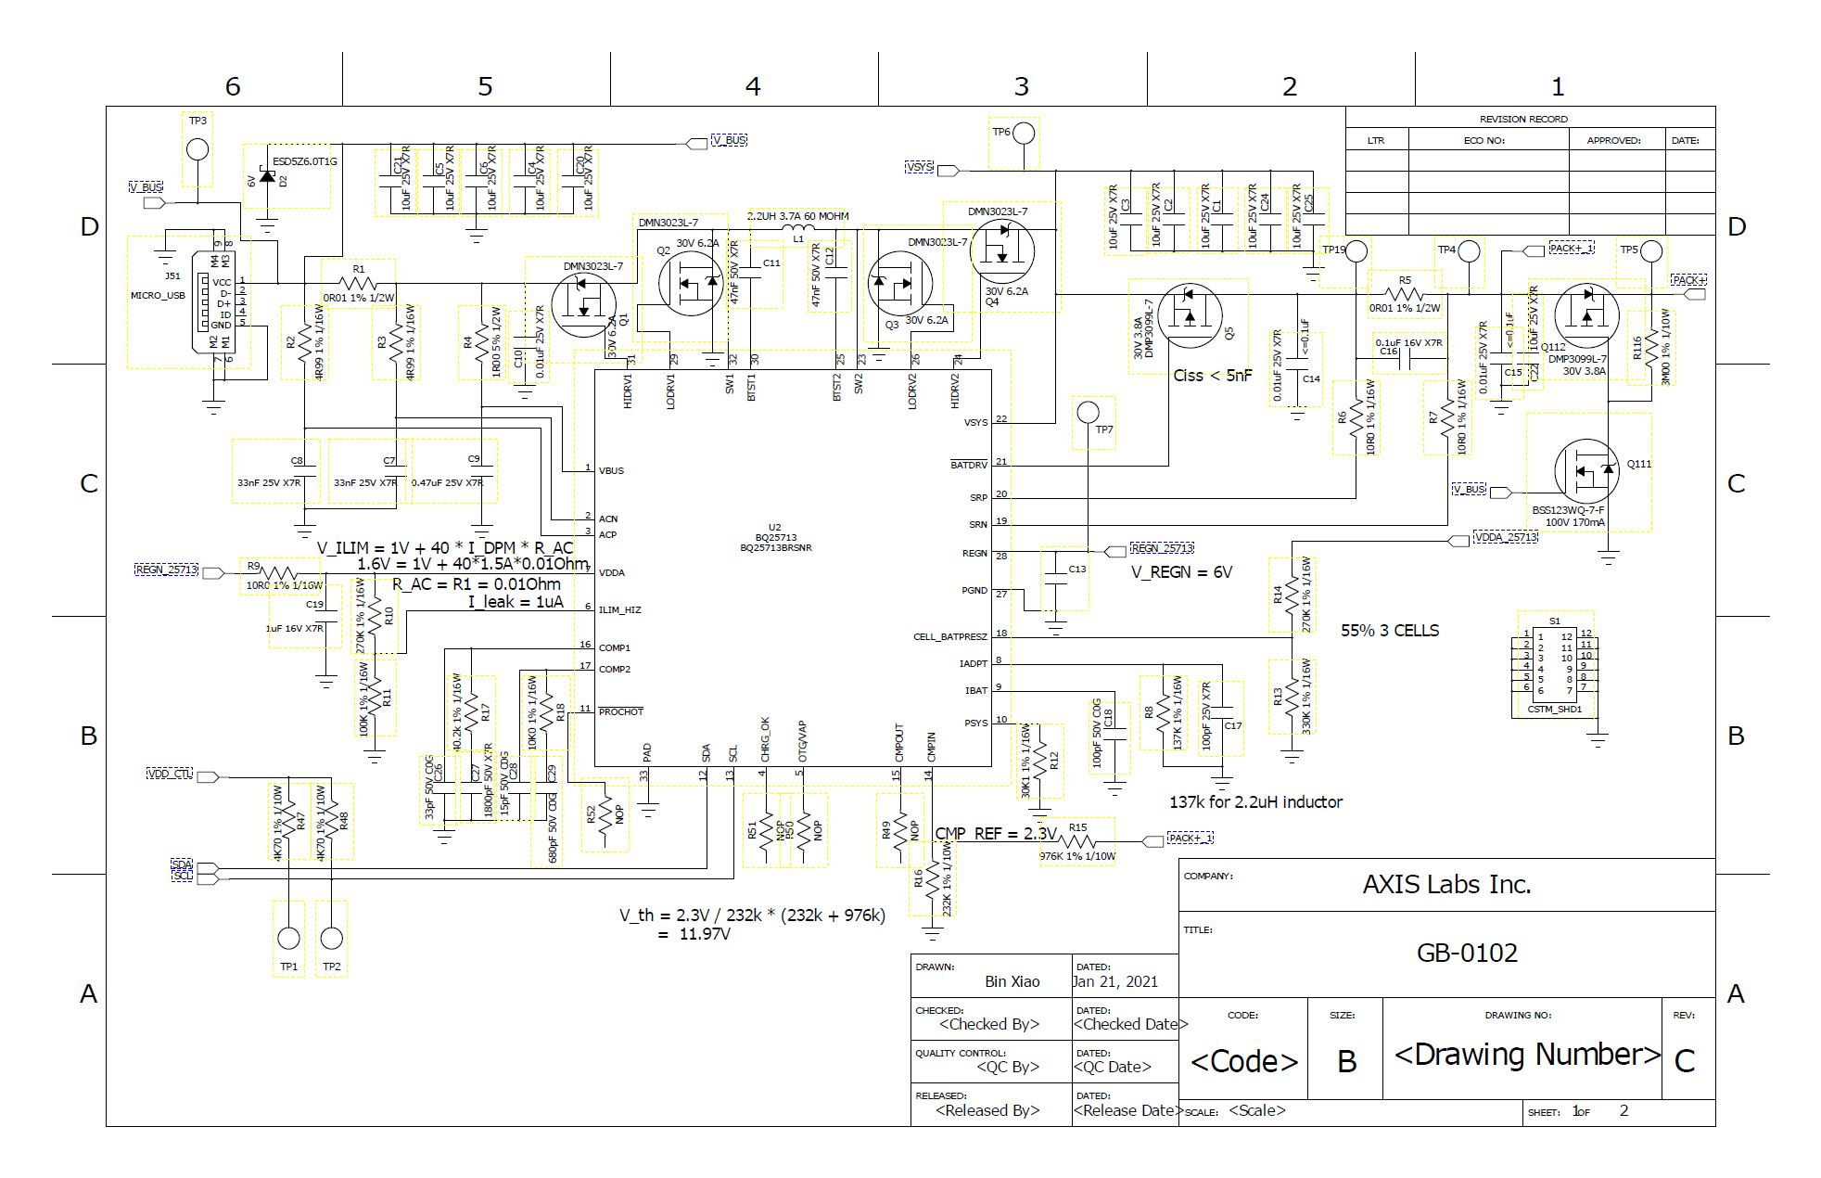
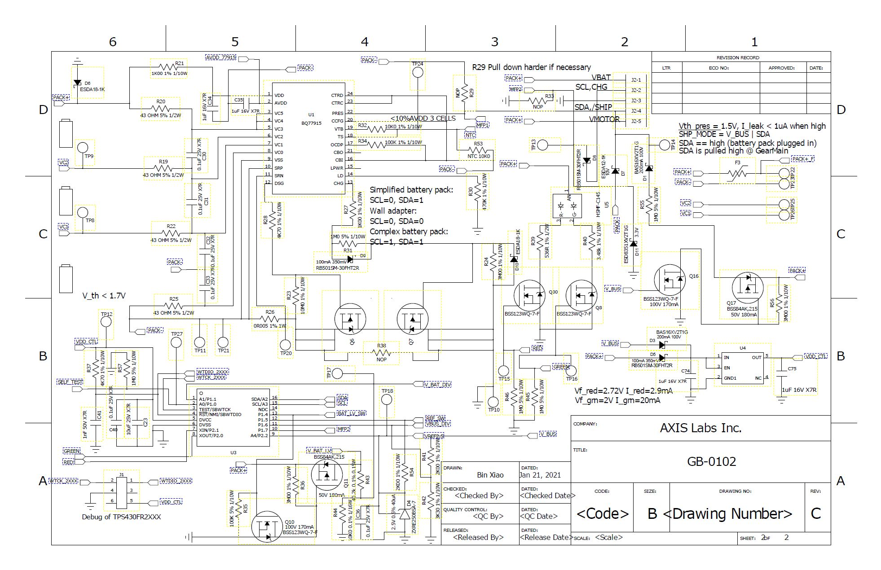
Note: the BQ77915(U1) and peripheral components are NOP. Please see the BOM for more details.
Bill Of Material:

